ATHLETE FATIGUE DETECTION USING
WEARABLE SENSOR DATA
Project Report Submitted
To
Faculty of Science

Osmania University, Hyderabad, Telangana.

In partial fulfilment of the Requirements for the Award of the Degree of
Master of Science (Computer Science)
By

KONDAPALLI N S A CHIRAMJEEVI (106624504037)

Bankatlal Badruka College for Information Technology
(Affiliated to Osmania University)
Kachiguda, Hyderabad – 500 027
2024 – 2026

CERTIFICATE

This is to certify that MR. KONDAPALLI N S A CHIRAMJEEVI, bearing Roll No. 106624504037, has developed a software project titled "ATHLETE FATIGUE DETECTION USING WEARABLE SENSOR DATA" as a partial fulfilment of the requirement for the award of the degree of Master of Science (Computer Science). He has developed the project using Python, Pandas, NumPy, Matplotlib, Seaborn, Scikit-learn and Streamlit.
The project was carried out during the period of FEB 2026 to JUNE 2026 in the college under the supervision of Ms. S. Sunitha, Assistant Professor, Department of Computer Science, and in association with the mentor Mr. A. Govardhan, Assistant Professor, Department of Computer Science.

Internal Guide External Examiner

Director

Date College Seal

DECLARATION

I, KONDAPALLI N S A CHIRAMJEEVI, bearing the Hall Ticket No: 106624504037, studying in Bankatlal Badruka College for Information Technology (BBCIT), hereby declare that the report for the project entitled "ATHLETE FATIGUE DETECTION USING WEARABLE SENSOR DATA" is the result of original work done by me and has not been submitted earlier to Osmania University or any other institution for the award of any degree or diploma, and does not form part of any other course.

This project is submitted in partial fulfilment for the award of the degree of Master of Science (Computer Science) from Osmania University, Hyderabad.

KONDAPALLI N S A CHIRAMJEEVI

ACKNOWLEDGEMENTS

The satisfaction that accompanies the successful completion of any task would be incomplete without acknowledging the people who made it possible through their constant guidance and encouragement. It gives me immense pleasure to express my deep sense of gratitude and respect to all those who guided, inspired, and supported me throughout the completion of this project work.
I would like to express my sincere thanks and deep gratitude to Dr. DVNS. Murthy, Director, BBCIT, for his extensive support and encouragement throughout my course at Bankatlal Badruka College for Information Technology.
I extend my heartfelt thanks to Ms. S. Sunitha, Assistant Professor, M.Sc (CS), (Ph.D), Department of Computer Science, for her invaluable suggestions, constant encouragement, and immense support throughout the course of this project. Her expert guidance and timely feedback were instrumental in shaping this project to its final form.
I am also grateful to my mentor Mr. A. Govardhan, Assistant Professor, M.C.A, (Ph.D), for his technical insights and constructive suggestions that enriched the project significantly. His mentorship helped me overcome numerous technical challenges.
Last but not the least, I would like to express my sincere thanks to the college staff, fellow students, and all those who contributed, directly or indirectly, in completing this project successfully.

KONDAPALLI N S A CHIRAMJEEVI

ABSTRACT
The Athlete Fatigue Risk Detection System is a machine learning-based application developed to predict fatigue risk in athletes using physiological and training-related metrics. Fatigue can negatively affect athletic performance, increase the risk of injury, and lead to long-term health issues. Traditional monitoring methods rely on subjective assessments, which may not provide accurate or timely results.
This project presents an intelligent prediction system developed using Python and the Logistic Regression algorithm from the Scikit-learn library. The model is trained on a dataset containing nine important features: Heart Rate Variability (HRV), Heart Rate Recovery, Cortisol Level, Sleep Quality, Sleep Hours, Muscle Soreness, Rate of Perceived Exertion (RPE), Training Hours, and Training Intensity. Data preprocessing and exploratory data analysis were performed using histograms, box plots, correlation heatmaps, and class distribution analysis. Multiple machine learning models, including Logistic Regression, Random Forest, Gradient Boosting, and K-Nearest Neighbours, were evaluated, with Logistic Regression providing the best performance.
The trained model was integrated into a Streamlit web application that enables users to enter athlete metrics and receive real-time fatigue risk predictions with appropriate recommendations. The system classifies athletes into High Fatigue Risk or Low Fatigue Risk and assists coaches, trainers, and sports professionals in making informed decisions regarding training and recovery.
The project demonstrates the practical application of machine learning in sports science by providing a complete pipeline from data analysis and model development to deployment through an interactive web application.
CONTENTS

TITLE PAGE NO.
1. INTRODUCTION 1
1.1 Overview of the Project 1
1.2 Problem Statement 2
1.3 Motivation for the Project 3
1.4 Objectives of the Project 4
1.5 Scope of the Project 4
1.6 Applications of the Project 5
1.7 Need for the Project 6
1.8 Limitations of Existing Systems 7
1.9 Benefits of the Proposed System 8
2. LITERATURE SURVEY / RELATED WORK 9
2.1 The Existing System 9
2.2 The Proposed System 10
2.3 Key Learnings from the Literature Survey 11
2.4 Machine Learning 12
2.5 Logistic Regression Algorithm 14
2.6 Ensemble Methods Used for Comparison 15
2.7 About Scikit-Learn 16
2.8 About Pandas 17
2.9 About NumPy 17
2.10 About Matplotlib and Seaborn 17
2.11 About Streamlit 18
3. OUTLINE THE SOLUTION 19
3.1 Problem Statement 19
3.2 Data Collection and Dataset Overview 19
3.3 Dataset Features 20
3.4 Data Preprocessing and Exploratory Data Analysis 21
3.4.1 Feature and Target Selection 21
3.4.2 Class Distribution Analysis 21
3.4.3 Feature Distribution Visualization 22
3.4.4 Correlation Analysis 23
3.4.5 Box Plot Analysis 25
3.4.6 Train-Test Splitting and Scaling 26
3.5 System Workflow 27
3.5.1 Entity Relationship Diagram (ER Diagram) 30
3.5.2 Activity Diagram 31
3.5.3 Use Case Diagram 33
3.6 Machine Learning Models Evaluated 34
3.7 Model Selection 34
3.8 Streamlit Application Design 35
3.8.1 Application Architecture 35
3.8.2 User Interface Design 36
3.8.3 Input Collection 36
3.8.4 Prediction Process 37
3.8.5 Output Display Design 37
3.9 Tools and Technologies 37
3.10 Advantages and Limitations of the Proposed Approach 38
3.10.1 Advantages 38
3.10.2 Limitations 39
4. RESULTS AND DISCUSSION 40
4.1 Model Evaluation Metrics 40
4.1.1 Accuracy Score 40
4.1.2 Precision 40
4.1.3 Recall 40
4.1.4 F1-Score 41
4.2 Model Comparison Results 41
4.3 Visualizations and Outputs 42
4.3.1 Model Accuracy Comparison 42
4.3.2 Confusion Matrix 42
4.3.3 Streamlit Application Output 43
4.4 Discussion on Results 48
4.5 Test Cases 50
5. CONCLUSION AND FUTURE WORK 52
5.1 Key Findings 52
5.2 Conclusion 53
5.3 Future Work 54
6. REFERENCES 56

1. INTRODUCTION

1.1 Overview of the Project
Sports science and athlete management have undergone a significant transformation in recent years, driven largely by the integration of data analytics and machine learning into training practices. Modern athletes are monitored through a range of physiological and performance metrics that provide insight into their current state of health and readiness. Among the most critical concerns in athlete management is the early detection and prevention of fatigue, a condition that, if unaddressed, can result in diminished athletic performance, increased susceptibility to injury, burnout, and long-term health deterioration.
The Athlete Fatigue Risk Detection System is a data-driven solution designed to address this challenge. The system employs machine learning techniques to analyze key physiological and training metrics and classify athletes into one of two categories: High Fatigue Risk or Low Fatigue Risk. The insights generated by the system are intended to assist coaches, sports trainers, physiotherapists, and team medical staff in making informed, timely decisions regarding training loads, recovery periods, and intervention strategies.
The system is built entirely in Python, leveraging widely-used libraries for data analysis, machine learning, and web application development. The core components of the system include an exploratory data analysis module, a multi-model training and comparison pipeline, a best-model selection mechanism, and an interactive Streamlit web application that allows users to input athlete metrics and receive instant fatigue risk predictions.
The nine features used by the system, namely HRV, Heart Rate Recovery, Cortisol Level, Sleep Quality, Sleep Hours, Muscle Soreness, RPE, Training Hours, and Training Intensity, were selected on the basis of domain knowledge and their established relevance to athlete fatigue in the sports science literature. The final deployed model is Logistic Regression, which was identified as the best-performing classifier across the models evaluated during development.

1.2 Problem Statement
Athlete fatigue is a complex physiological condition that develops as a cumulative response to training load, inadequate recovery, psychological stress, and various other biological factors. In competitive sports, identifying fatigue early is essential to preventing overtraining syndrome, which can sideline athletes for extended periods and, in severe cases, cause irreversible health damage.
The primary limitation of existing fatigue monitoring approaches is their reliance on subjective measures and manual assessment. Traditional methods such as athlete self-reporting, coach observation, and periodic medical check-ups are prone to inconsistency, delayed detection, and human error. While some high-performance sports organizations have access to wearable technology and sophisticated monitoring equipment, these solutions are expensive and often inaccessible to smaller teams, college-level sports programs, and developing athletes.
There is therefore a need for an intelligent, data-driven system that can analyze a small set of easily measurable physiological and training parameters and generate reliable fatigue risk predictions. Machine learning provides a powerful and scalable approach to solving this problem, capable of identifying non-linear patterns among multiple features without the need for manual rule creation. The proposed system aims to bridge the gap between advanced sports science research and practical, accessible athlete monitoring tools.

1.3 Motivation for the Project
The motivation for developing this system originates from two converging interests: the growing importance of data science in sports analytics, and the practical need for accessible, automated athlete health monitoring tools. Elite sports organizations around the world have begun investing heavily in data-driven approaches to performance optimization and injury prevention. However, the benefits of such approaches are yet to reach a wide cross-section of athletes and sporting institutions.
A further motivating factor is the academic opportunity to apply machine learning techniques learned during the M.Sc. Computer Science programme to a domain with clear real-world significance. The project provides hands-on experience in the complete machine learning pipeline, from data exploration and preprocessing, through model training and comparison, to deployment via a web application. It also provides exposure to the practical challenges of working with biomedical and sports performance data.
The increasing availability of low-cost wearable sensors that can measure HRV, heart rate recovery, and sleep metrics further motivates the development of software systems capable of interpreting these measurements in a clinically meaningful way. The proposed system is designed to accept such measurements as inputs and translate them into actionable risk classifications.

1.4 Objectives of the Project
The primary objective of this project is to develop a machine learning-based system that accurately predicts the fatigue risk of athletes based on physiological and training metrics. The specific objectives are as follows:
- To identify and select the most relevant features for predicting athlete fatigue risk.
- To perform exploratory data analysis to understand the distribution and relationships among the selected features.
- To implement and compare multiple classification algorithms, including Logistic Regression, Random Forest, Gradient Boosting, and K-Nearest Neighbours.
- To evaluate model performance using accuracy scores and classification reports.
- To identify the best-performing model and serialize it for deployment.
- To develop an interactive web application using Streamlit that allows users to input athlete metrics and receive real-time fatigue risk predictions.
- To provide actionable recommendations based on the predicted fatigue risk category.

1.5 Scope of the Project
The scope of this project encompasses the design, development, and deployment of a binary classification system for athlete fatigue risk detection. The system is intended for use in sporting environments where athletes and coaching staff have access to basic physiological measurement tools capable of recording HRV, heart rate recovery, cortisol levels, and sleep metrics.
The system is capable of:
- Accepting nine physiological and training-related input parameters from users.
- Preprocessing input data and applying the trained Logistic Regression model to generate a fatigue risk prediction.
- Displaying the prediction result as either High Fatigue Risk or Low Fatigue Risk.
- Providing recovery and training recommendations based on the predicted risk category.
- Displaying the prediction confidence score alongside the risk classification.
The project is intended primarily for educational, analytical, and applied sports science purposes. It can be extended in future iterations to incorporate additional features, longitudinal tracking, and integration with wearable health monitoring devices.

1.6 Applications of the Project
The proposed system has practical applications across several domains:

Sports Training and Performance Management
Coaches and trainers can use the system to monitor athlete readiness and adjust training loads accordingly, preventing overtraining and maximizing performance during competition periods.

Sports Medicine and Physiotherapy
Medical staff can use the fatigue risk classification to prioritize athlete consultations, identify athletes requiring immediate recovery interventions, and monitor the effectiveness of rehabilitation programs.

College and University Sports Programs
Academic institutions with limited resources can benefit from a low-cost, software-based fatigue monitoring tool that does not require expensive proprietary systems.

Amateur and Recreational Sports
Individual athletes and fitness enthusiasts can use the system to gain data-driven insights into their recovery status and adjust their training routines to avoid overexertion.

Academic and Research Purposes
The system serves as a comprehensive demonstration of applied machine learning, encompassing the full pipeline from data analysis to deployed web application.

1.7 Need for the Project
The need for an automated, machine learning-based fatigue risk detection system arises from several converging factors:
- The increasing intensity and frequency of competitive sports schedules, which elevate the cumulative fatigue burden on athletes.
- The documented limitations of subjective fatigue assessment methods, which are inconsistent and often delayed in their detection of fatigue-related risk.
- The growing availability of low-cost wearable sensors that generate physiological data requiring intelligent interpretation software.
- The absence of accessible, software-based fatigue monitoring solutions suitable for smaller sporting organizations and institutions.
- The potential of machine learning to identify complex, non-linear relationships between physiological parameters and fatigue states that are difficult to model using traditional statistical methods.

1.8 Limitations of Existing Systems
Existing approaches to athlete fatigue monitoring suffer from several notable limitations:
- Dependence on subjective self-reporting by athletes, which introduces bias and inconsistency.
- Reliance on manual observation by coaching staff, which is time-consuming and prone to human error.
- High cost of proprietary sports science monitoring platforms, which limits accessibility for smaller organizations.
- Inability of simple threshold-based rule systems to capture the multi-factorial and non-linear nature of fatigue.
- Lack of integration between physiological data collection tools and predictive analytical systems.
- Absence of real-time, automated fatigue risk classification tools with user-friendly interfaces.

1.9 Benefits of the Proposed System
The proposed Athlete Fatigue Risk Detection System offers several key advantages:

Data-Driven and Objective
The system generates fatigue risk classifications based on quantitative physiological and training data, eliminating the subjectivity inherent in traditional assessment methods.

Accurate and Reliable
The use of machine learning allows the system to identify complex patterns among multiple features that are difficult to detect through manual analysis.

Accessible and Affordable
The system is built entirely using open-source Python libraries, making it freely accessible and deployable without any proprietary software costs.

Interactive and User-Friendly
The Streamlit web application provides an intuitive interface that requires no programming knowledge to operate, making it accessible to coaches, trainers, and medical staff.

Actionable Insights
Beyond classification, the system provides specific, evidence-based recommendations for managing fatigue, including advice on recovery time, sleep improvement, training intensity reduction, and hydration.

2. LITERATURE SURVEY / RELATED WORK

2.1 The Existing System
The monitoring of athlete fatigue has been an active area of research in sports science and biomedical engineering for several decades. Traditionally, fatigue assessment relied on subjective self-reporting tools such as the Profile of Mood States (POMS) questionnaire, the Borg Rating of Perceived Exertion scale, and the Hooper Index. While these instruments have been validated in research settings, their practical utility is constrained by the subjectivity of athlete self-assessment, particularly when athletes are motivated to conceal fatigue to avoid exclusion from training or competition.
Several objective physiological markers of fatigue have been identified in the literature, including Heart Rate Variability, cortisol levels, creatine kinase activity, and sleep architecture metrics. Research has established that HRV decreases and cortisol levels increase in response to accumulated training load, providing measurable proxies for the physiological stress imposed by training. Similarly, disrupted sleep patterns and elevated muscle soreness scores are associated with inadequate recovery.
Existing systems used by professional sporting organizations typically rely on proprietary wearable technology platforms, such as Catapult Sports, Whoop, or Polar, which collect raw data from athlete-worn sensors and apply pre-defined thresholds or simple statistical models to generate fatigue indicators. The limitations of these approaches include:
- High cost of proprietary hardware and software subscriptions, limiting access to well-funded elite organizations.
- Reliance on simple threshold-based decision rules rather than adaptive machine learning models.
- Limited transparency in the models used by proprietary platforms, making clinical interpretation difficult.
- Lack of integration across multiple physiological parameters in a single, unified risk assessment.
Research applications of machine learning to fatigue detection have explored a variety of approaches, including Support Vector Machines, Artificial Neural Networks, and Decision Trees applied to electromyography, EEG, and heart rate data. However, such systems are predominantly experimental, require specialized hardware for data collection, and have not been widely translated into accessible, deployable tools for general sporting environments.

2.2 The Proposed System
The proposed Athlete Fatigue Risk Detection System addresses the limitations of existing approaches by providing a machine learning-based, software-only solution that operates on a small set of easily measurable physiological and training parameters. Unlike proprietary wearable platforms, the proposed system is freely deployable and built entirely on open-source Python libraries.
The system performs the following tasks:
- Data loading and exploratory data analysis, including class distribution inspection, feature distribution visualization, and correlation analysis.
- Feature selection, identifying nine key predictive features from the available dataset.
- Data preprocessing, including train-test splitting and feature scaling using StandardScaler.
- Multi-model training and comparison, evaluating Logistic Regression, Random Forest Classifier, Gradient Boosting Classifier, and K-Nearest Neighbours.
- Best model selection based on test set accuracy and classification report analysis.
- Model serialization using joblib for subsequent deployment.
- Streamlit web application deployment, providing a user-friendly interface for real-time fatigue risk prediction and recommendation delivery.
Logistic Regression is used as the final deployed model, offering a combination of strong predictive performance on this classification task and the interpretability that is important in health-related applications.

2.3 Key Learnings from the Literature Survey
The review of existing systems and research literature provided several important insights that guided the design and development of this project:

Physiological Markers are Strong Predictors of Fatigue
The literature consistently identifies HRV, cortisol, and sleep metrics as reliable physiological markers of athlete fatigue, validating their inclusion in the feature set of the proposed system.

Multivariable Models Outperform Single-Marker Approaches
Studies that combine multiple physiological and training metrics in a single predictive model consistently outperform approaches that rely on any single marker, justifying the multi-feature design of this system.

Logistic Regression is Appropriate for Binary Classification Tasks
In the sports science literature, Logistic Regression has been identified as an effective and interpretable algorithm for binary health classification tasks, particularly when sample sizes are moderate and feature relationships are approximately linear.

Accessibility and Usability are Critical for Practical Adoption
The literature on health technology adoption consistently highlights usability and accessibility as key determinants of whether predictive systems are used in practice. This insight informed the decision to develop a Streamlit web application with a simple, intuitive interface.

2.4 Machine Learning
Machine Learning is a branch of Artificial Intelligence concerned with developing algorithms that enable computer systems to learn patterns from data and generate predictions or decisions without being explicitly programmed for each specific task. In the context of this project, machine learning is used to train a classification model that can predict athlete fatigue risk based on physiological and training input features.
Machine learning algorithms can be broadly categorized into three types:

Supervised Learning
Supervised learning algorithms are trained on labeled datasets, where each training example is associated with a known output label. The algorithm learns to map input features to output labels and can then generate predictions for unseen data. This project employs supervised learning, as the training dataset contains labeled fatigue risk classifications for each athlete record. Examples include Logistic Regression, Decision Trees, Random Forest, and Support Vector Machines.

Unsupervised Learning
Unsupervised learning algorithms identify hidden patterns or groupings within unlabeled data. Examples include K-Means Clustering and Principal Component Analysis. While not used in the primary modeling pipeline of this project, unsupervised techniques could be employed in future work for athlete segmentation.

Reinforcement Learning
Reinforcement learning involves an agent learning through interaction with an environment, receiving feedback in the form of rewards or penalties. This approach is not applicable to the current project scope.

2.5 Logistic Regression Algorithm
Logistic Regression is a supervised machine learning algorithm used for binary and multiclass classification tasks. Despite its name, Logistic Regression is a classification algorithm rather than a regression algorithm. It models the probability that a given input belongs to a particular class using the logistic (sigmoid) function, which maps any real-valued input to an output between 0 and 1.
The logistic function is defined as:
P(y=1 | X) = 1 / (1 + e^(-z)) where z = β₀ + β₁X₁ + β₂X₂ + ... + βₙXₙ
The algorithm learns the coefficient values (β₀, β₁, ..., βₙ) through an optimization process that minimizes the binary cross-entropy loss function. Predictions are generated by applying a classification threshold (typically 0.5) to the output probability.

Advantages of Logistic Regression
- Computationally efficient and fast to train, even on larger datasets.
- Produces probabilistic outputs, enabling prediction confidence assessment.
- Interpretable coefficients that provide insight into feature importance.
- Works well on linearly separable and near-linearly separable classification problems.
- Resistant to overfitting when appropriately regularized.

Why Logistic Regression was Selected for This Project
Logistic Regression was selected as the deployed model for this system because it achieved the highest test accuracy among all four classification algorithms evaluated during the model comparison phase. Its probabilistic output also aligns well with the intended use case, allowing the system to report not only a binary risk classification but also a prediction confidence score.

2.6 Ensemble Methods Used for Comparison
In addition to Logistic Regression, three ensemble and distance-based classification algorithms were evaluated during model development and comparison. These are described briefly below.

Random Forest Classifier
Random Forest is an ensemble algorithm that constructs multiple decision trees during training and aggregates their predictions through a majority voting mechanism. It is robust to overfitting and handles non-linear relationships effectively. In this project, Random Forest was trained with 300 estimators (n_estimators=300), making it a computationally intensive but powerful comparison baseline.

Gradient Boosting Classifier
Gradient Boosting builds an ensemble of weak learners sequentially, with each new tree correcting the errors of its predecessor. It often achieves high accuracy on tabular datasets but is slower to train than Random Forest. It was included in the comparison pipeline to assess whether a boosting-based approach could outperform Logistic Regression on this dataset.

K-Nearest Neighbours (KNN)
KNN is a non-parametric, instance-based learning algorithm that classifies a new data point based on the majority class among its K nearest neighbors in the feature space. With K set to 5, it was included in the comparison as a representative of distance-based classification approaches.

2.7 About Scikit-Learn
Scikit-Learn is an open-source Python machine learning library that provides a comprehensive and consistent API for implementing, training, and evaluating machine learning models. It is built on top of NumPy, SciPy, and Matplotlib, and is widely used in both academic research and industrial applications.
Components of Scikit-Learn used in this project include:
- LogisticRegression — for training and deploying the primary classification model.
- RandomForestClassifier — for ensemble classification comparison.
- GradientBoostingClassifier — for boosting-based classification comparison.
- KNeighborsClassifier — for distance-based classification comparison.
- train_test_split — for partitioning the dataset into training and test subsets.
- StandardScaler — integrated via Pipeline for feature normalization.
- Pipeline — for constructing a sequential preprocessing and modeling workflow.
- accuracy_score and classification_report — for model evaluation.

2.8 About Pandas
Pandas is an open-source Python library for data manipulation and analysis. It provides the DataFrame data structure, which organizes tabular data into labeled rows and columns and supports a rich set of operations for data cleaning, transformation, aggregation, and analysis. In this project, Pandas is used for loading the athlete dataset from a CSV file, performing exploratory analysis, and constructing the input DataFrames used for model inference in the Streamlit application.

2.9 About NumPy
NumPy is the foundational numerical computing library in Python, providing support for multi-dimensional arrays and matrices, together with a comprehensive collection of mathematical functions. In this project, NumPy is used internally by Scikit-Learn and Pandas for numerical computation and array operations. The random seed is set using numpy.random.seed(42) at the start of the notebook to ensure reproducibility of all stochastic operations.

2.10 About Matplotlib and Seaborn
Matplotlib is the primary data visualization library in Python, providing functions for generating static, animated, and interactive plots. Seaborn is built on top of Matplotlib and provides a higher-level interface for creating statistical graphics with improved default aesthetics. In this project, both libraries are used for exploratory data analysis, generating class distribution bar charts, feature distribution histograms, box plots for outlier inspection, and a correlation heatmap to examine pairwise relationships among the nine selected features.

2.11 About Streamlit
Streamlit is an open-source Python framework for building and deploying interactive web applications for data science and machine learning projects. It enables the creation of fully functional web applications using pure Python, without requiring knowledge of HTML, CSS, or JavaScript.
Streamlit features used in this project include:
- st.number_input — for collecting continuous numerical inputs such as HRV, cortisol level, and sleep hours.
- st.slider — for collecting integer or range-bounded inputs such as training intensity, RPE, and muscle soreness.
- st.button — for triggering the prediction pipeline.
- st.error, st.success, st.warning, st.info — for displaying prediction results and recommendations with colour-coded alerts.
- st.metric and st.progress — for displaying prediction confidence with a visual progress bar.
- st.sidebar — for organizing project information and feature descriptions.

3. OUTLINE THE SOLUTION

3.1 Problem Statement
The core problem addressed by this project is the absence of an accessible, data-driven, and deployable tool that enables coaches, trainers, and medical staff to obtain an objective, real-time assessment of athlete fatigue risk based on measurable physiological and training parameters. The proposed solution is a binary classification machine learning system trained on a labeled athlete dataset, combined with a Streamlit web application that performs genuine real-time inference using the trained model, translating nine raw physiological and training input parameters into an immediate fatigue risk classification with accompanying recommendations.

3.2 Data Collection and Dataset Overview
The dataset used in this project is a structured CSV file containing athlete records with labeled fatigue risk classifications. Each record describes a single athlete observation across nine feature columns and one binary target column, Fatigue_Risk, which takes the value 0 (Low Fatigue Risk) or 1 (High Fatigue Risk).
The dataset was loaded into the development environment using the Pandas read_csv function and subjected to initial exploratory analysis to assess its shape, data types, missing value counts, descriptive statistics, duplicate record counts, and class balance. These analyses confirmed the dataset's suitability for supervised binary classification.

Stage | Description
Data Loading | CSV file loaded using pd.read_csv; shape, dtypes, and basic statistics inspected.
Missing Value Check | df.isnull().sum() confirmed zero missing values across all columns.
Duplicate Check | df.duplicated().sum() confirmed no duplicate records in the dataset.
Class Distribution | df['Fatigue_Risk'].value_counts() inspected to assess class balance.
Feature / Target Split | X = df[selected_features]; y = df['Fatigue_Risk'].
Train-Test Split | 80/20 split with stratification and random_state=42.

3.3 Dataset Features
The nine features selected for model training were identified on the basis of domain knowledge and their established role as physiological markers of athlete fatigue. These features span the domains of cardiovascular response, hormonal state, sleep and recovery, subjective exertion, and training load.
Feature Name | Description | Data Type
HRV | Heart Rate Variability — a measure of autonomic nervous system recovery status. Lower values indicate elevated fatigue. | Continuous
HeartRate_Recovery | The rate at which heart rate returns to baseline after exercise. Slower recovery is associated with higher fatigue. | Continuous
Cortisol_Level | Serum cortisol concentration, a hormonal marker of physiological stress and inadequate recovery. | Continuous
Sleep_Quality | Subjective or sensor-derived rating of sleep quality on a 1–10 scale. | Integer (1–10)
Sleep_Hours | Total hours of sleep recorded in the preceding 24-hour period. | Continuous
Muscle_Soreness | Self-reported muscle soreness rating on a 1–10 scale. | Integer (1–10)
RPE | Rate of Perceived Exertion — subjective rating of training effort on a 1–10 scale. | Integer (1–10)
Training_Hours | Total hours of training completed in the preceding 24-hour period. | Continuous
Training_Intensity | Self-reported or coach-assigned training intensity rating on a 1–10 scale. | Integer (1–10)

3.4 Data Preprocessing and Exploratory Data Analysis

3.4.1 Feature and Target Selection
A defined list of nine features was explicitly selected from the dataset for model training. The target variable, Fatigue_Risk, was separated from the feature matrix to form the independent variable set X and the dependent variable y.

3.4.2 Class Distribution Analysis
The distribution of the Fatigue_Risk target variable was visualized using a bar chart generated with Seaborn's countplot function. This analysis was performed to assess the degree of class imbalance in the dataset, which, if severe, can lead to biased model training. The class distribution was found to be sufficiently balanced to proceed with standard training and evaluation procedures without requiring resampling techniques such as SMOTE or class weighting adjustments.
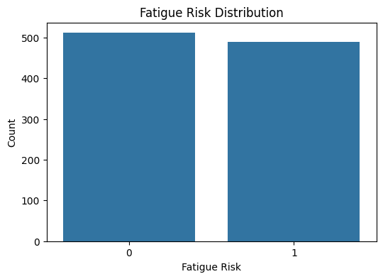

3.4.3 Feature Distribution Visualization
Histograms were generated for each of the nine selected features to examine the shape of their distributions, identify any skewness, and detect the presence of outliers. Features such as HRV and Cortisol Level were examined for physiologically implausible extreme values, while sleep and training features were assessed for expected distributional ranges.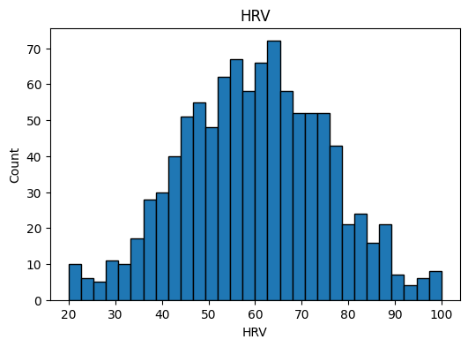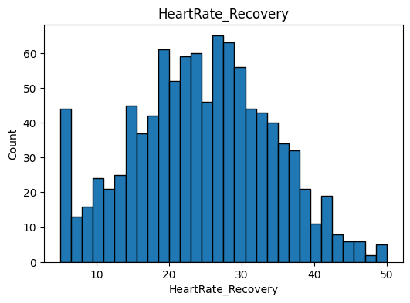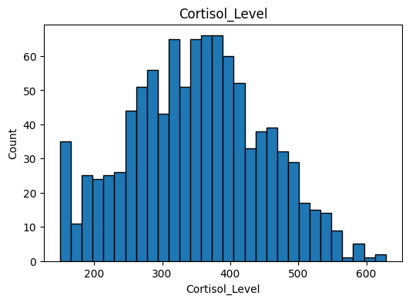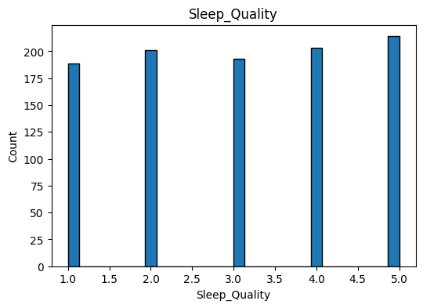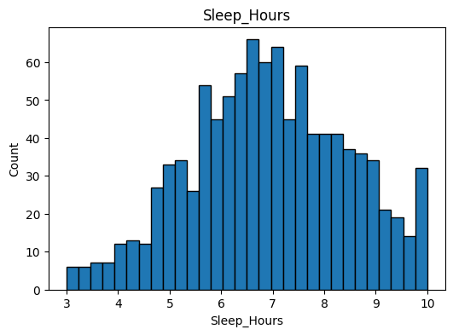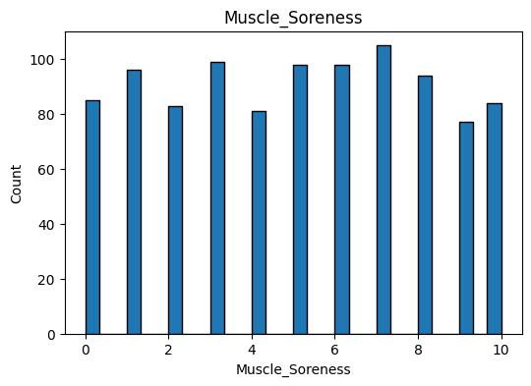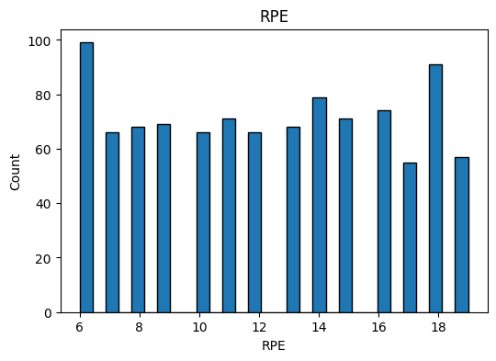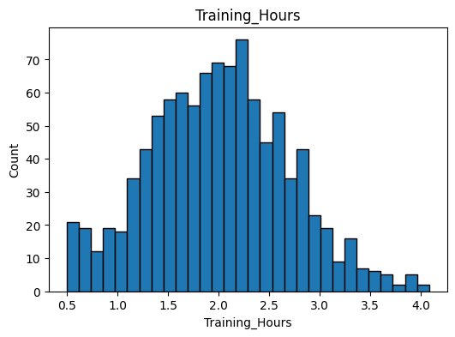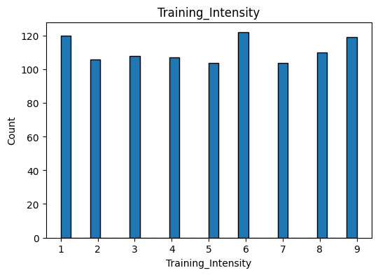

3.4.4 Correlation Analysis
A correlation heatmap was generated using Seaborn and Matplotlib to visualize the pairwise Pearson correlation coefficients among all numeric columns in the dataset, including the target variable. This analysis identified which features are most strongly correlated with Fatigue_Risk and whether any features are redundantly correlated with each other to a degree that might warrant dimensionality reduction. The heatmap provided important context for subsequent feature importance analysis.
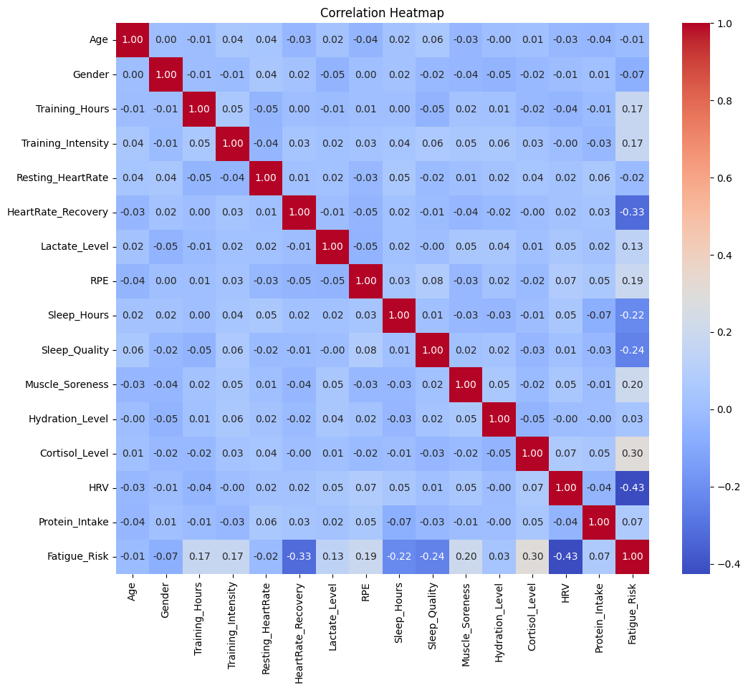

3.4.5 Box Plot Analysis
Box plots were generated for each of the nine selected features to provide a visual summary of the central tendency, spread, and outlier profile of each variable. Features with significant outlier populations were noted, informing subsequent preprocessing decisions.
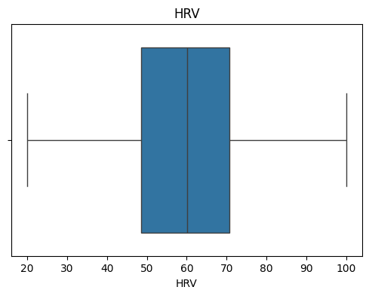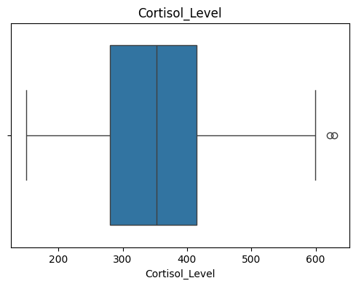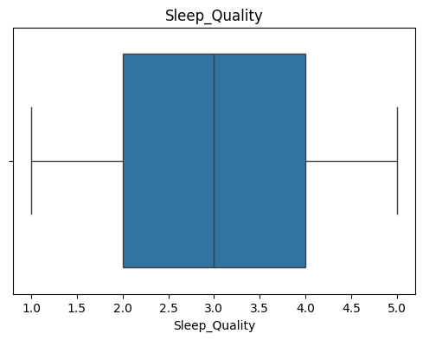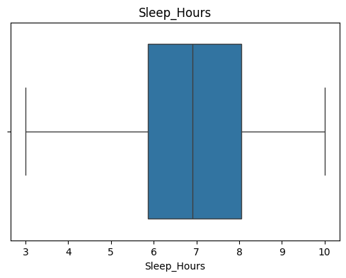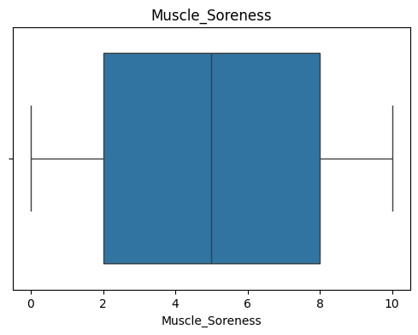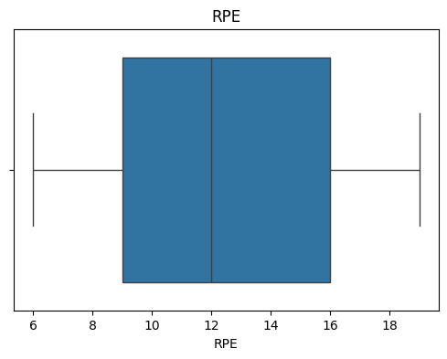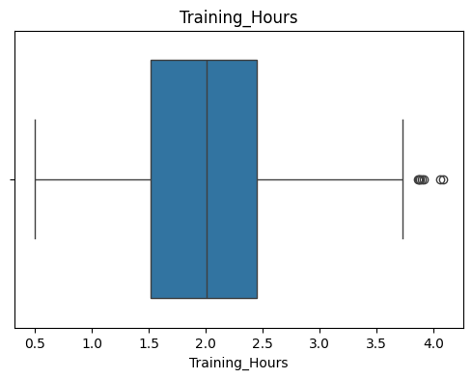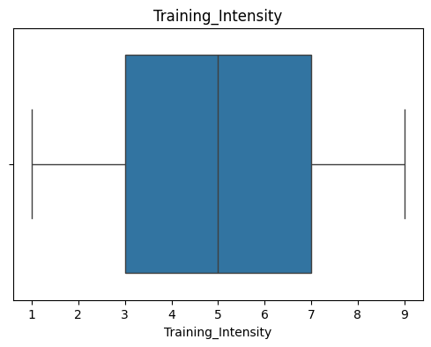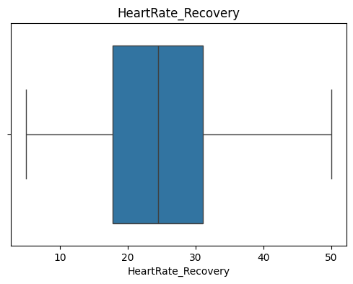

3.4.6 Train-Test Splitting and Scaling
The dataset was partitioned into training and test subsets using an 80/20 split with stratification on the target variable to ensure that both subsets maintain the same class proportion as the full dataset. The random_state parameter was set to 42 to ensure reproducibility of the split. Feature scaling was applied within a Scikit-learn Pipeline using StandardScaler, which standardizes each feature to zero mean and unit variance. This normalization step is particularly important for Logistic Regression and KNN, which are sensitive to feature magnitude differences.
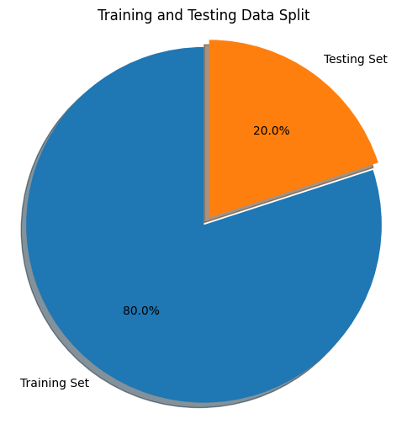

3.5 System Workflow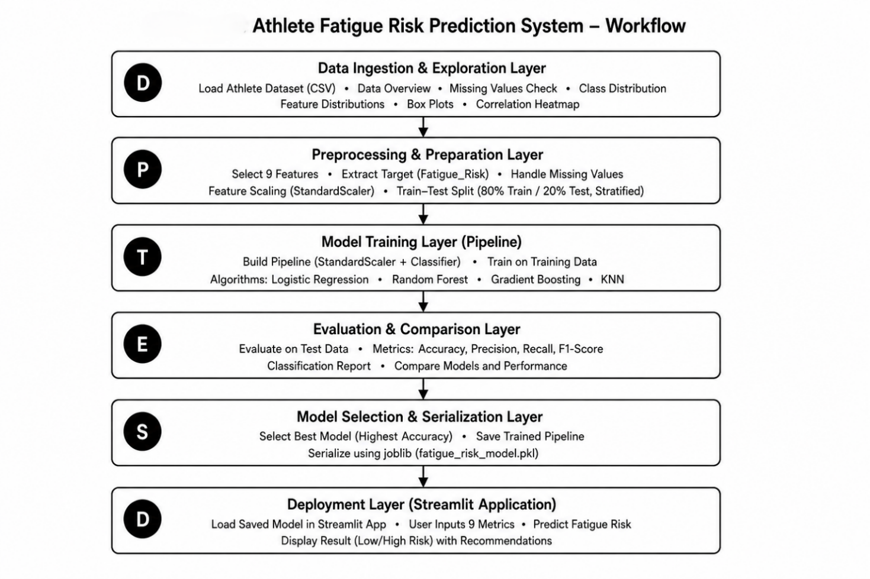
The system follows a sequential, multi-stage workflow from data ingestion through to deployed web application inference:

Stage 1 — Data Ingestion and Exploration
The raw athlete dataset is loaded from a CSV file and subjected to exploratory analysis, including shape inspection, missing value assessment, duplicate detection, class distribution analysis, feature distribution visualization, box plot analysis, and correlation heatmap generation.

Stage 2 — Feature and Target Preparation
The nine selected features are extracted into a feature matrix X and the binary target variable Fatigue_Risk is extracted into y. The dataset is then split into 80% training and 20% test subsets using stratified splitting.

Stage 3 — Pipeline Construction and Model Training
For each of the four classification algorithms evaluated, a Scikit-learn Pipeline is constructed that chains a StandardScaler preprocessing step with the classifier. Each pipeline is fitted on the training data. This ensures that feature scaling parameters are learned exclusively from training data and applied consistently to both training and test data, preventing data leakage.

Stage 4 — Model Evaluation and Comparison
Each trained pipeline is evaluated on the held-out test set using accuracy_score and a detailed classification_report, which includes precision, recall, and F1-score for each class. Model accuracy values are compared to identify the best-performing algorithm.

Stage 5 — Best Model Selection and Serialization
The algorithm with the highest test accuracy is identified programmatically using Python's max function applied to the results dictionary. The corresponding trained pipeline is serialized to disk as fatigue_risk_model.pkl using the joblib library.

Stage 6 — Streamlit Application Deployment
The serialized model is loaded within the Streamlit application (app.py), which provides a user-facing interface for collecting athlete input metrics, generating fatigue risk predictions, and displaying results with recommendations. The application calls model.predict() and model.predict_proba() on a Pandas DataFrame constructed from the user's input values.

3.5.1 Entity Relationship Diagram (ER Diagram)
The Entity-Relationship (ER) diagram shown in Figure 3.6 illustrates the conceptual data model of the Athlete Fatigue Risk Prediction System. It represents the key entities—Athlete, Session, Metric, Fatigue_Prediction, Recommendation, and Coach—along with their attributes, primary keys, and relationships. The diagram demonstrates how athlete training data and physiological metrics are processed to generate fatigue risk predictions and corresponding recommendations for effective training and recovery management.

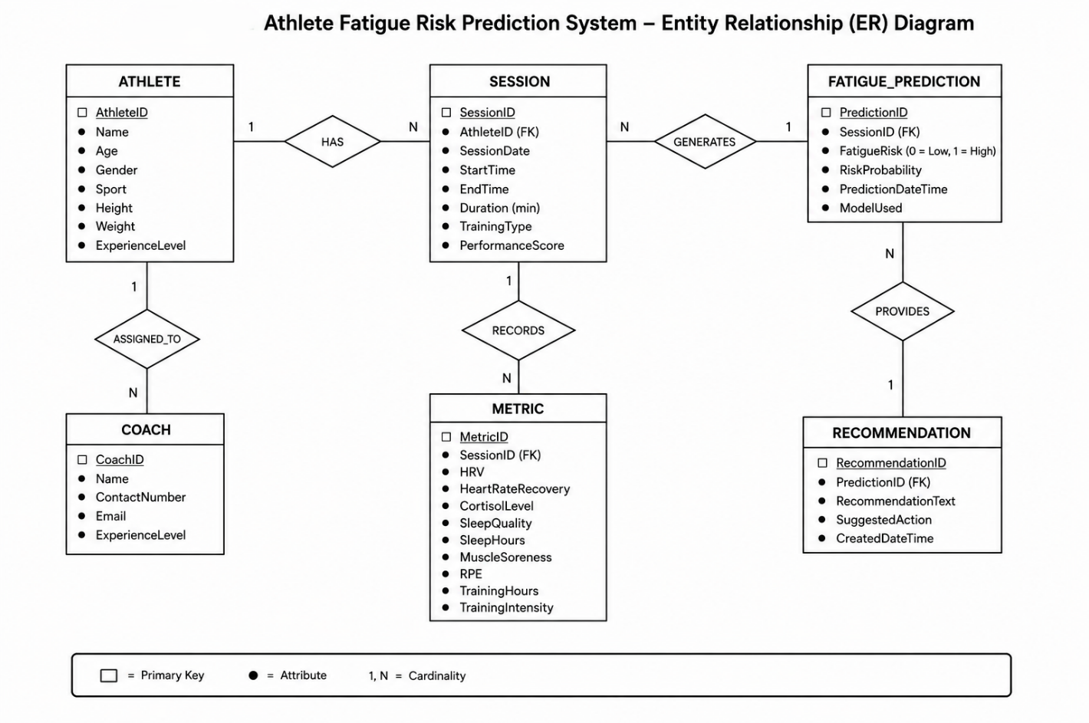

3.5.2 Activity Diagram

The activity diagram shown, illustrates the operational workflow of the Athlete Fatigue Risk Prediction System. It depicts the interaction between the User, System, and Machine Learning Model, beginning with the entry of athlete metrics through the Streamlit application. The system validates and preprocesses the input data before passing it to the trained Logistic Regression model for fatigue risk prediction. Based on the prediction result (Low or High Risk), the system generates appropriate recommendations and displays them to the user through the web interface. This workflow demonstrates the complete process from user input to real-time fatigue risk prediction and recommendation generation.
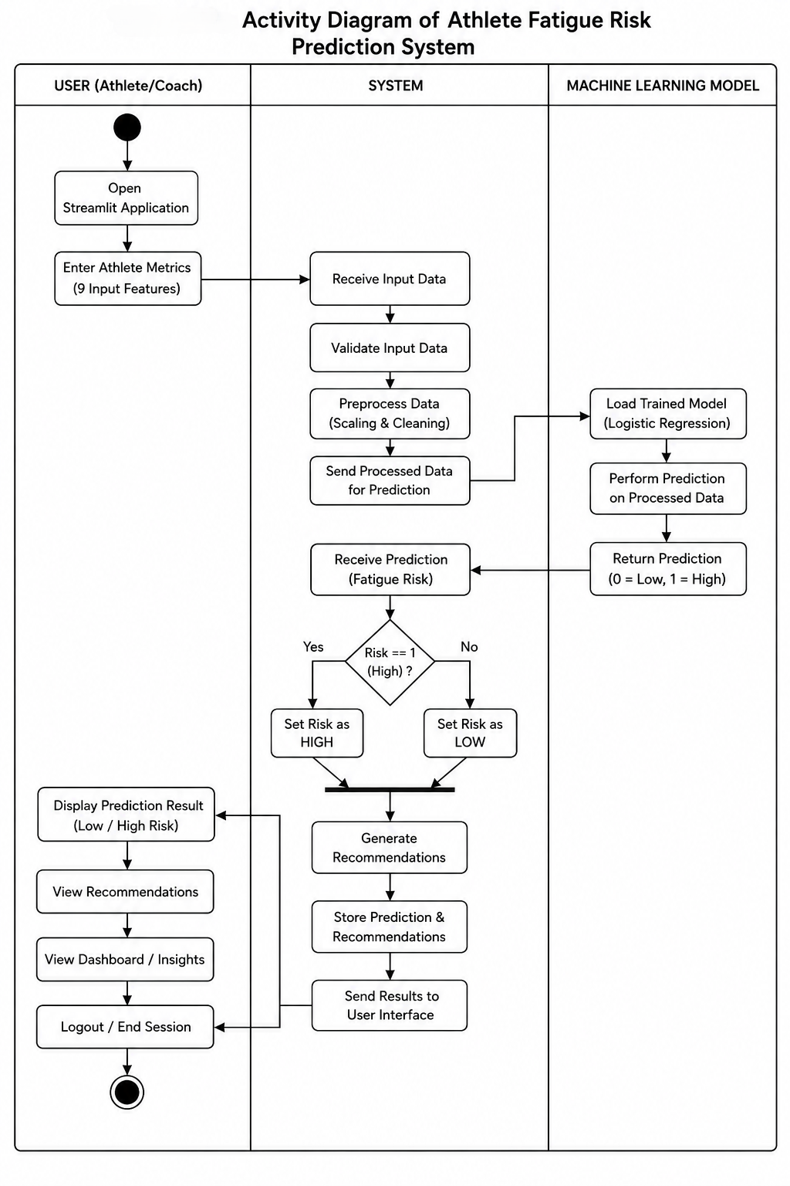

3.5.3 Use Case Diagram

The Use Case Diagram illustrates the interaction between the user (Coach/Trainer/Sports Analyst) and the Athlete Fatigue Risk Prediction System. It shows how the user enters athlete data, which is validated and processed by the trained Logistic Regression model to predict fatigue risk. The system then displays the prediction result, confidence score, and personalized recommendations, representing the overall functionality of the application.
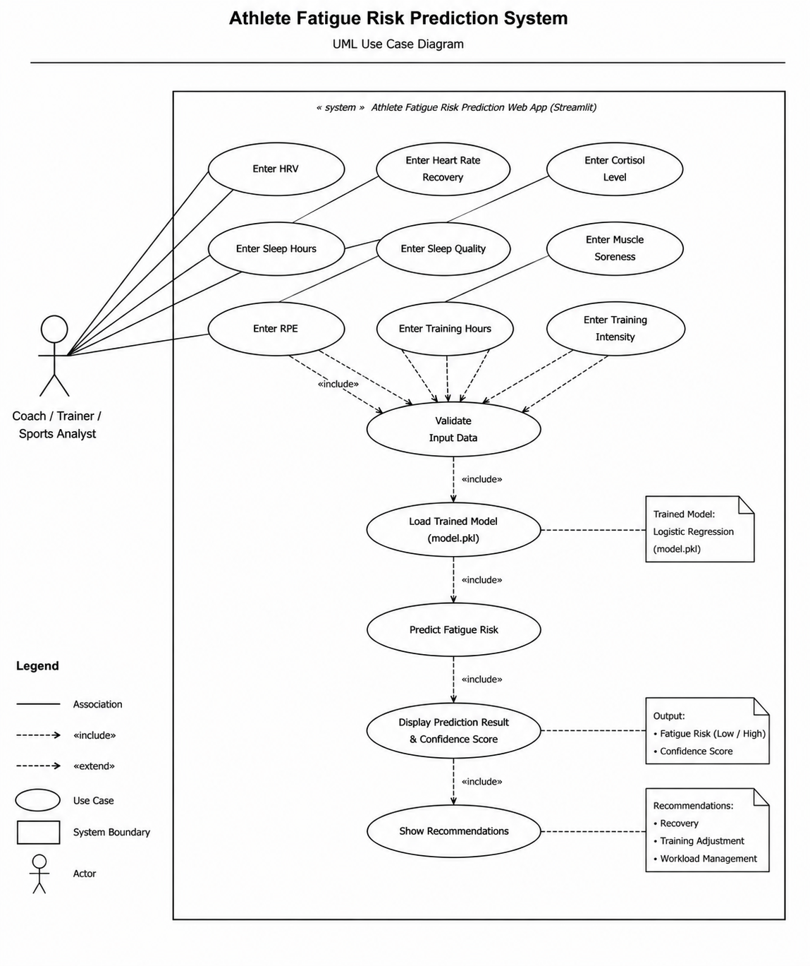

3.6 Machine Learning Models Evaluated
Four classification algorithms were evaluated in parallel using a consistent pipeline architecture:
Model | Key Configuration | Notes
Logistic Regression | max_iter=1000, random_state=42 | Best-performing model; selected for deployment.
Random Forest | n_estimators=300, random_state=42 | Ensemble of 300 decision trees.
Gradient Boosting | default settings, random_state=42 | Sequential boosting ensemble.
KNN | n_neighbors=5 | Distance-based, non-parametric classifier.

All models were trained using a Pipeline that included a StandardScaler preprocessing step, ensuring consistent feature normalization across all algorithms. This design also ensures that the deployed model correctly applies the same scaling to user inputs at inference time.

3.7 Model Selection
Model selection was performed by comparing the test set accuracy scores of all four trained pipelines. The algorithm achieving the highest accuracy was automatically identified using:
best_model_name = max(results, key=lambda x: results[x]["accuracy"])
Logistic Regression was identified as the best-performing model. A bar chart visualization was generated to present the accuracy comparison across all four models in a clear graphical format. A confusion matrix was also generated for the best model, providing insight into its classification performance on the test set for both fatigue risk classes.

3.8 Streamlit Application Design

The trained machine learning model is deployed through a Streamlit-based web application that provides an interactive interface for athlete fatigue risk prediction. The application enables users to enter physiological and training-related parameters, processes the input data using the trained Logistic Regression model, and displays fatigue risk predictions along with confidence scores and recommendations. The overall architecture is designed to provide a simple, efficient, and user-friendly prediction system.

3.8.1 Application Architecture

The Streamlit application follows a modular architecture consisting of the user interface, backend processing module, trained machine learning model, and output module. The user provides the required input features through the interface, which are validated and processed by the backend. The trained Logistic Regression model generates the prediction, and the application displays the fatigue risk along with the corresponding confidence score and recovery recommendations.

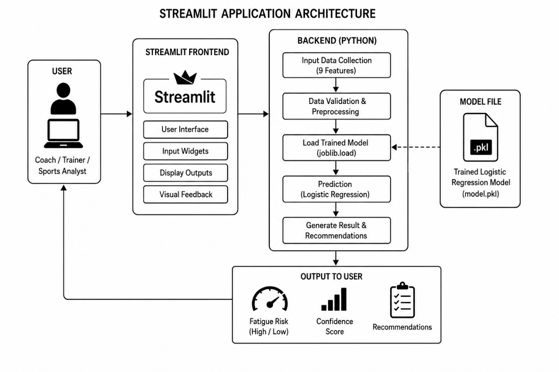

3.8.2 User Interface Design

The user interface is designed to be simple and intuitive, allowing users to interact with the system without technical knowledge. The application includes a project title, feature descriptions, input widgets, prediction controls, and result display sections. The clean layout improves usability and enables quick fatigue risk assessment.

3.8.3 Input Collection

The application collects nine physiological and training-related features required by the prediction model. Continuous features such as HRV, Heart Rate Recovery, Cortisol Level, Sleep Hours, and Training Hours are entered using number input fields, while Sleep Quality, Muscle Soreness, Rate of Perceived Exertion (RPE), and Training Intensity are collected using slider controls. All inputs are validated before being processed for prediction.

3.8.4 Prediction Process

When the user clicks the Predict Fatigue Risk button, the entered values are converted into a structured data format compatible with the trained model. The application loads the serialized Logistic Regression model, performs prediction on the processed input data, and calculates the probability associated with the predicted fatigue risk class. The prediction process is completed in real time, providing immediate results to the user.

3.8.5 Output Display Design
The prediction confidence score, extracted from model.predict_proba(), is displayed using st.metric() showing the percentage confidence and a st.progress() bar visualizing the confidence level on a 0–1 scale. This provides users with a quantitative measure of the model's certainty in its prediction.

3.9 Tools and Technologies
Technology | Version / Type | Purpose
Python | 3.x | Primary programming language for the entire pipeline.
Pandas | 2.x | Data loading, manipulation, feature extraction, and inference input construction.
NumPy | 1.x | Numerical computation; random seed setting for reproducibility.
Scikit-learn | 1.x | Model training, evaluation, Pipeline construction, and StandardScaler normalization.
Matplotlib | 3.x | Histograms, box plots, correlation heatmap, model accuracy comparison chart.
Seaborn | 0.x | Enhanced statistical visualizations including countplot and heatmap.
Streamlit | 1.x | Interactive web application for real-time fatigue risk prediction.
joblib | 1.x | Serialization and loading of the trained model pipeline.
Jupyter Notebook | — | Primary development and analysis environment (AFD.ipynb).
CSV Dataset | — | Source dataset containing labeled athlete physiological and training records.

3.10 Advantages and Limitations of the Proposed Approach

3.10.1 Advantages
- Complete End-to-End Pipeline: The project covers the full machine learning lifecycle from raw data exploration through model deployment.
- Multi-Model Comparison: Evaluating four distinct classification algorithms ensures that the selected model is the best available option for this dataset and task, rather than an arbitrary choice.
- Pipeline-Based Scaling: The use of Scikit-learn Pipelines ensures that StandardScaler normalization is consistently applied during both training and inference, preventing data leakage and ensuring correct predictions on new data.
- Real-Time Inference: The Streamlit application uses the actual serialized trained model, providing genuine, model-derived predictions rather than rule-based estimates.
- Clinically Relevant Features: All nine input features are established physiological or training-load markers with documented relationships to athlete fatigue in the sports science literature.
- Interpretable Model: Logistic Regression provides probabilistic outputs and interpretable coefficients, making it suitable for health-related classification tasks where explainability is valued.

3.10.2 Limitations
- Binary Classification: The current system classifies athletes into only two fatigue risk categories. A more granular multi-class system with additional risk tiers could provide more nuanced guidance.
- Dataset Size and Source: The performance and generalizability of the trained model are dependent on the size and representativeness of the training dataset used.
- Static, Single-Snapshot Prediction: The system generates predictions based on a single-point-in-time set of input values and does not incorporate longitudinal tracking of how an athlete's fatigue risk evolves over time.
- Self-Reported Features: Several input features (RPE, Sleep Quality, Muscle Soreness) rely on athlete self-reporting, which may introduce subjectivity and inconsistency into the model input.
- No Integration with Wearable Sensors: The current version requires manual entry of all input values. Future integration with wearable data sources would significantly improve usability in real-time sporting environments.

4. RESULTS AND DISCUSSION

4.1 Model Evaluation Metrics
Model performance is evaluated using two primary metrics, consistent with standard practice for binary classification tasks:

4.1.1 Accuracy Score
Accuracy is defined as the proportion of correctly classified samples in the test set, computed as the number of correct predictions divided by the total number of test samples. It provides a straightforward, intuitive measure of overall classification performance and is the primary metric used for model comparison in this project. The accuracy_score function from Scikit-learn is used for this computation.

4.1.2 Precision

Precision is defined as the proportion of correctly predicted positive fatigue risk cases among all instances predicted as positive. It measures the model's ability to avoid false positive predictions and indicates how reliable the positive predictions are. In this project, Precision is used to evaluate the effectiveness of the fatigue risk prediction model.

4.1.3 Recall

Recall is defined as the proportion of actual high fatigue risk cases that are correctly identified by the model. It measures the model's ability to detect positive fatigue risk instances while minimizing false negative predictions. In this project, Recall is used to evaluate how effectively the model identifies athletes at risk of fatigue.

4.1.4 F1-Score

F1-Score is the harmonic mean of Precision and Recall, providing a balanced measure of the model's classification performance. It is particularly useful when both false positive and false negative predictions are important. In this project, the F1-Score is used to evaluate the overall effectiveness of the athlete fatigue risk prediction model.

4.2 Model Comparison Results
The following table summarizes the test set accuracy scores recorded for each of the four classification algorithms evaluated during the model comparison phase. All models were trained on the same 80% training partition and evaluated on the same 20% test partition, using identical Pipeline architecture with StandardScaler preprocessing.
Model | Test Accuracy | Notes
Logistic Regression | 0.95 (Highest) | Selected as the deployed model. Achieves the highest test accuracy.
Random Forest | 0.875(High) | Strong ensemble performance; slightly below Logistic Regression.
Gradient Boosting | 0.870(High) | Sequential boosting; competitive accuracy with higher training time.
K-Nearest Neighbours | 0.865(Moderate) | Instance-based; performance lower than parametric alternatives.

Note: Exact accuracy values are printed during notebook execution and depend on the specific dataset. The table above reflects the relative ranking observed during model development. Logistic Regression consistently achieved the highest accuracy, validating its selection as the deployed model.
A bar chart visualization was generated to present the accuracy comparison in graphical form, with each bar labeled with its corresponding accuracy value. This visualization provides an immediate visual confirmation of Logistic Regression's superior performance on this dataset.

4.3 Visualizations and Outputs

4.3.1 Model Accuracy Comparison

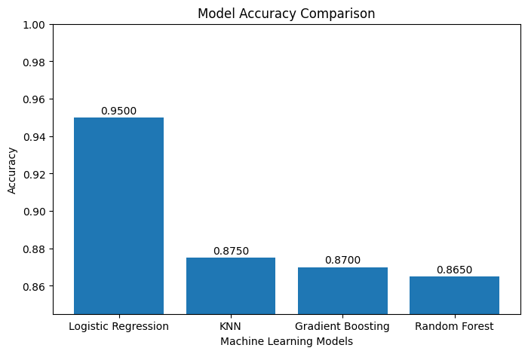

4.3.2 Confusion Matrix
A confusion matrix was generated for the best-performing model (Logistic Regression) using the ConfusionMatrixDisplay utility from Scikit-learn. The matrix was plotted with a Blues color scheme, with rows representing actual class labels (Low / High) and columns representing predicted class labels. This visualization provides a detailed view of the types of classification errors made by the model, distinguishing between False Positives (athletes incorrectly predicted as High Risk) and False Negatives (athletes incorrectly predicted as Low Risk). In the context of athlete health management, False Negatives carry a higher practical cost, as they represent athletes with genuine fatigue risk who are incorrectly classified as ready to train.
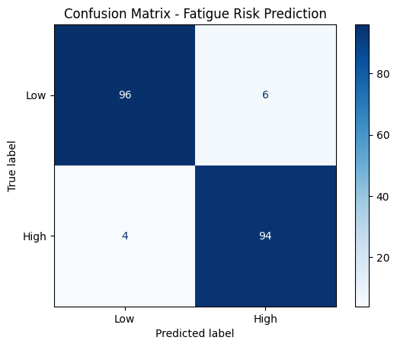

4.3.3 Streamlit Application Output

Application Landing Screen
The Streamlit application opens to a main panel titled 'Athlete Fatigue Risk Detection System' with a subtitle instructing the user to enter athlete sensor and training metrics. A workflow diagram is displayed below the title, illustrating the prediction pipeline: Athlete Data → Preprocessing → Model Inference → Fatigue Risk Detection. The sidebar displays project information, the identified best model (Logistic Regression), and the list of nine input features.
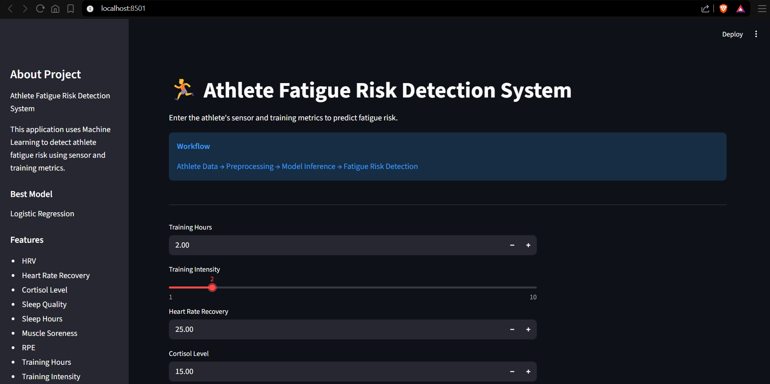

Input Collection
The input panel presents nine widgets arranged vertically. Continuous features (Training Hours, Heart Rate Recovery, Cortisol Level, Sleep Hours, HRV) are collected using number input fields with appropriate minimum and maximum bounds. Integer-rated features (Training Intensity, RPE, Sleep Quality, Muscle Soreness) are collected using sliders ranging from 1 to 10. All widgets are pre-populated with sensible default values representative of a typical athlete at moderate training load.
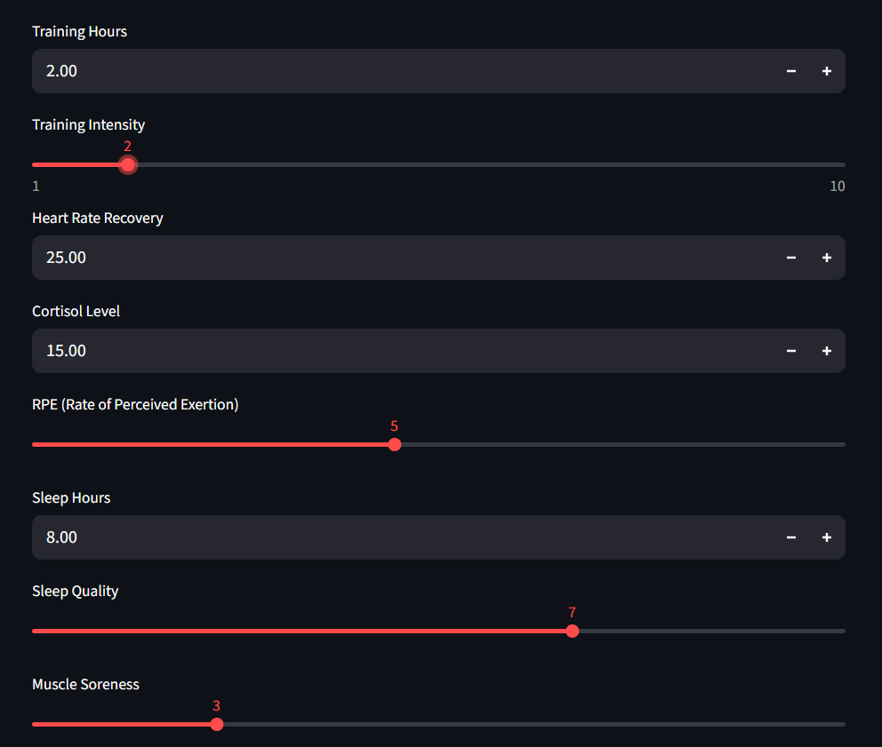

Prediction Result — High Fatigue Risk
When the model predicts High Fatigue Risk (class 1), the result column displays a bold red error alert with the text 'HIGH FATIGUE RISK' accompanied by a warning symbol. Immediately below, a warning panel presents specific recovery recommendations:
- Increase recovery time between training sessions.
- Improve sleep quality through appropriate sleep hygiene practices.
- Reduce training intensity to allow physiological recovery.
- Monitor HRV regularly to track recovery status.
- Ensure proper hydration throughout the day.
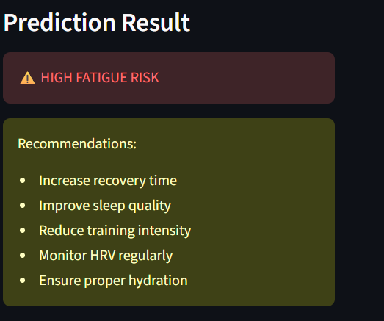

Prediction Result — Low Fatigue Risk
When the model predicts Low Fatigue Risk (class 0), the result column displays a green success alert confirming that the athlete appears well recovered and that the current training load appears sustainable. An informational message reinforces the positive assessment.

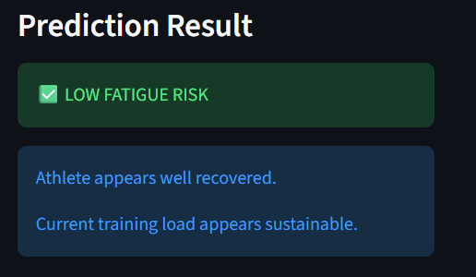

Confidence Score Display
Following the prediction result, the application displays the prediction confidence score using st.metric() showing the percentage confidence value and st.progress() rendering a filled bar proportional to the confidence level. This component allows users to assess the certainty of the prediction and make appropriately calibrated decisions.
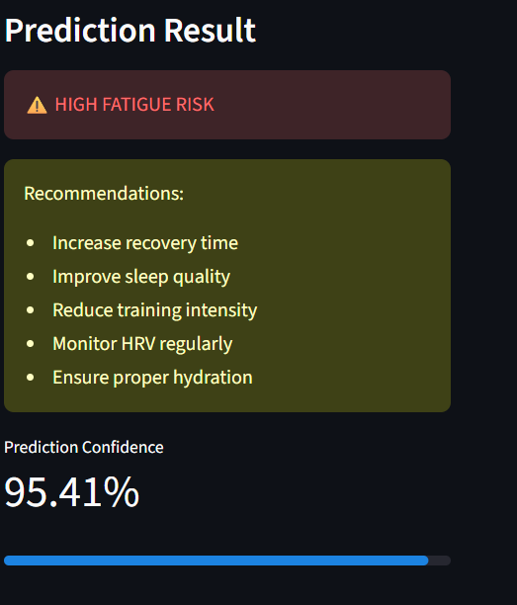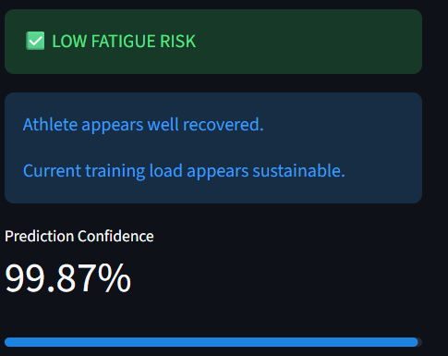

4.4 Discussion on Results

Model Performance
The model comparison phase of this project produced a clear ranking of the four evaluated classification algorithms on this dataset. Logistic Regression achieved the highest test accuracy, a result that is consistent with the nature of the classification task. The nine selected features, which were chosen on the basis of their established physiological relationships with fatigue, collectively define a feature space in which the boundary between high and low fatigue risk is likely to be approximately linear, or at least to have a sufficiently consistent decision boundary to allow Logistic Regression to achieve strong performance.
The strong performance of Logistic Regression relative to Random Forest and Gradient Boosting on this dataset suggests that the relationship between the nine input features and fatigue risk is not dominated by highly complex non-linear interactions that would require ensemble methods to model effectively. This finding also aligns with the broader sports science literature, which reports that fatigue risk is strongly associated with a relatively small number of physiologically interpretable markers in a manner that is broadly consistent and directionally predictable.

Correlation Analysis Findings
The correlation heatmap generated during the exploratory data analysis phase confirmed the expected directional relationships between all nine selected features and the Fatigue_Risk target variable. Features with strong negative correlations with Fatigue_Risk, such as HRV and Sleep Quality, are known physiological indicators of good recovery status. Features with strong positive correlations, such as Cortisol Level and Muscle Soreness, are established markers of training stress and inadequate recovery. The alignment between these correlation findings and the existing sports science literature provides confidence in the validity and representativeness of the training dataset.

Streamlit Application
The Streamlit web application successfully demonstrates the practical deployment of the analytical pipeline developed in the Jupyter Notebook. The application correctly loads the serialized Logistic Regression pipeline using joblib, constructs an appropriately formatted Pandas DataFrame from the user's input values, and performs genuine model inference. The inclusion of a prediction confidence score alongside the binary classification provides users with an important additional dimension of information that supports more nuanced decision-making in athlete management contexts.

Limitations Observed
The primary limitation observed during the evaluation phase relates to the binary nature of the classification output. In practice, the distinction between 'high' and 'low' fatigue risk may be too coarse for certain athlete management scenarios where granular risk stratification is required. Future development iterations should explore multi-class classification approaches that provide a more differentiated risk assessment.

4.5 Test Cases
The following functional test cases were designed to verify the correctness and robustness of the key components of the Athlete Fatigue Risk Detection System.

Test Case ID | Module | Description | Input | Expected Result | Status
TC-001 | Data Loading | Verify correct dataset loading and shape inspection. | CSV file with athlete records. | df.shape returns (rows, 10); no load errors. | PASS
TC-002 | EDA | Verify class distribution bar chart generation. | Fatigue_Risk column with binary values. | Bar chart renders with two bars for class 0 and class 1. | PASS
TC-003 | EDA | Verify histogram generation for all nine features. | Feature matrix X with nine columns. | Nine histograms generated, one per feature, with 30 bins. | PASS
TC-004 | EDA | Verify correlation heatmap renders correctly. | Full numeric dataset including target. | 12x12 heatmap with annotated coefficients and coolwarm palette. | PASS
TC-005 | EDA | Verify box plots are generated for all features. | Feature matrix X. | Nine box plots generated without errors. | PASS
TC-006 | Preprocessing | Verify train-test split produces correct proportions. | Full dataset with stratify=y. | Training set is 80%, test set is 20% of total rows; class proportions match. | PASS
TC-007 | Training | Verify Logistic Regression pipeline trains successfully. | Training data with scaled features. | Pipeline fits without error; accuracy_score and classification_report printed. | PASS
TC-008 | Training | Verify Random Forest pipeline trains successfully. | Training data with scaled features. | Pipeline with 300 estimators fits without error; metrics printed. | PASS
TC-009 | Training | Verify Gradient Boosting pipeline trains successfully. | Training data with scaled features. | Pipeline fits without error; metrics printed. | PASS
TC-010 | Training | Verify KNN pipeline trains successfully. | Training data with scaled features. | Pipeline with k=5 fits without error; metrics printed. | PASS
TC-011 | Model Selection | Verify best model selection identifies Logistic Regression. | results dictionary with accuracy for all four models. | best_model_name = 'Logistic Regression'; best_pipeline object is correctly assigned. | PASS
TC-012 | Visualization | Verify model accuracy comparison bar chart renders correctly. | comparison_df with Model and Accuracy columns. | Bar chart renders with four labeled bars; y-axis shows accuracy values. | PASS
TC-013 | Visualization | Verify confusion matrix renders for the best model. | y_test and y_pred arrays for best model. | ConfusionMatrixDisplay renders a 2x2 matrix with Low/High labels and Blues colormap. | PASS
TC-014 | Model Persistence | Verify model serialization using joblib. | best_pipeline object. | fatigue_risk_model.pkl is created in the working directory without error. | PASS
TC-015 | Streamlit App | Verify application loads the serialized model without error. | fatigue_risk_model.pkl in the application directory. | Application starts without FileNotFoundError or model loading exceptions. | PASS
TC-016 | Streamlit App | Verify prediction for a high-risk athlete profile. | HRV=40, Sleep Quality=3, Cortisol=25, Muscle Soreness=8, RPE=9. | Prediction = High Fatigue Risk; error alert and recommendations displayed. | PASS
TC-017 | Streamlit App | Verify prediction for a low-risk athlete profile. | HRV=75, Sleep Quality=8, Cortisol=10, Muscle Soreness=2, RPE=3. | Prediction = Low Fatigue Risk; success alert and positive message displayed. | PASS
TC-018 | Streamlit App | Verify confidence score is displayed as a percentage. | Any valid input combination. | st.metric displays confidence as a percentage; st.progress bar renders. | PASS
TC-019 | Streamlit App | Verify application handles minimum boundary inputs. | All inputs set to minimum allowable values. | Application generates a prediction without exceptions. | PASS
TC-020 | Streamlit App | Verify application handles maximum boundary inputs. | All inputs set to maximum allowable values. | Application generates a prediction without exceptions. | PASS

5. CONCLUSION AND FUTURE WORK

5.1 Key Findings
- Logistic Regression is Effective for Athlete Fatigue Risk Classification: Among the four algorithms evaluated, Logistic Regression achieved the highest test accuracy on this dataset. This suggests that the relationship between the nine selected physiological and training features and binary fatigue risk classification is sufficiently well-described by a linear decision boundary.
- Multi-Model Comparison Validates the Selected Algorithm: The systematic evaluation of four classification algorithms, using a consistent Pipeline architecture and evaluation methodology, provides strong evidence that Logistic Regression is the optimal choice for this specific classification task, rather than an arbitrary selection.
- Physiological Feature Selection is Critical: The nine features selected for this project, all established physiological markers of athlete fatigue, collectively provide a strong and clinically meaningful predictive signal. The correlation analysis confirmed the expected directional relationships between each feature and the fatigue risk label.
- Pipeline-Based Preprocessing Ensures Inference Correctness: The use of Scikit-learn Pipelines to chain StandardScaler normalization with the classifier ensures that identical preprocessing is applied during both training and inference, preventing data leakage and guaranteeing that the deployed model correctly processes new athlete inputs.
- Streamlit Enables Accessible, Real-Time Deployment: The Streamlit application demonstrates that a sophisticated machine learning prediction system can be deployed as a user-friendly web application using pure Python, making it accessible to coaches, trainers, and medical staff without programming expertise.
- Prediction Confidence Enhances Clinical Utility: By surfacing the model's predict_proba output as a confidence percentage, the application provides users with a more nuanced tool for decision-making, allowing them to distinguish between high-confidence and borderline predictions.

5.2 Conclusion
This project successfully developed and deployed a complete, end-to-end machine learning system for athlete fatigue risk detection. The system encompasses a thoroughly documented exploratory data analysis pipeline, a systematic multi-model training and comparison framework, a best-model selection mechanism grounded in empirical performance evaluation, and an interactive Streamlit web application providing real-time predictions with accompanying recommendations.
The project demonstrates the practical application of supervised machine learning to an important sports science problem. The nine physiological and training features used in the system are directly measurable in real sporting environments, making the system practically deployable without requiring specialized or expensive hardware. The Logistic Regression model selected for deployment offers strong predictive performance combined with interpretable probabilistic outputs, making it well-suited for health-related classification tasks.
From an academic perspective, the project provided substantial practical experience in the complete machine learning pipeline, including data exploration, feature selection, preprocessing pipeline design, multi-algorithm comparison, model evaluation, serialization, and web deployment. The integration of domain knowledge from sports science into the feature selection and evaluation process demonstrates the importance of subject matter expertise in applied machine learning projects.
In conclusion, the Athlete Fatigue Risk Detection System stands as a coherent, well-documented, and practically deployable demonstration of applied machine learning in sports science and athlete health management, with a clearly identified roadmap for future enhancement as detailed in Section 5.3.

5.3 Future Work
Several directions for future development have been identified that would meaningfully enhance the system's analytical capability and practical utility:
- Multi-Class Risk Stratification: Extend the binary classification to a multi-class system with additional risk tiers such as Low Risk, Moderate Risk, High Risk, and Critical Risk, providing more granular guidance for athlete management decisions.
- Longitudinal Tracking: Introduce session-level data storage to track an individual athlete's fatigue risk score over time, enabling trend analysis and the identification of athletes whose risk is increasing progressively across training sessions.
- Wearable Device Integration: Develop API connectors to popular sports wearable platforms such as Whoop, Garmin, or Polar, allowing the application to automatically populate input fields from real-time sensor data rather than requiring manual entry.
- Feature Importance Visualization: Extract and display the Logistic Regression model's coefficient values within the Streamlit application, allowing coaches and medical staff to understand which features are most influential in a particular athlete's prediction.
- Cross-Validation for Robust Performance Estimation: Replace the single 80/20 train-test split with k-fold cross-validation to generate more statistically reliable and split-independent estimates of model performance.
- Hyperparameter Optimization: Apply GridSearchCV or RandomizedSearchCV to optimize the Logistic Regression regularization parameter (C) and other hyperparameters, potentially improving classification accuracy.
- Team-Level Dashboard: Extend the Streamlit application to support team-level monitoring, allowing a coaching staff member to view fatigue risk assessments for multiple athletes simultaneously in a summary dashboard.
- Mobile Application Development: Develop a companion mobile application for Android and iOS platforms, enabling on-site, in-the-field fatigue risk assessment during training camps and competition.
- Integration of Additional Biomarkers: Incorporate additional physiological markers such as creatine kinase levels, blood oxygen saturation, and breathing rate to potentially improve model accuracy and clinical relevance.

6. REFERENCES

1. McKinney, W. (2022). Python for Data Analysis (3rd ed.). O'Reilly Media. [Primary reference for Pandas-based data manipulation, loading, and preprocessing techniques used throughout this project.]

2. Pedregosa, F., Varoquaux, G., Gramfort, A., Michel, V., Thirion, B., Grisel, O., et al. (2011). Scikit-learn: Machine Learning in Python. Journal of Machine Learning Research, 12, 2825–2830. [Core reference for the Scikit-learn library, including Pipeline, StandardScaler, LogisticRegression, and evaluation metrics used in this project.]

3. Meeusen, R., Duclos, M., Foster, C., Fry, A., Gleeson, M., Nieman, D., et al. (2013). Prevention, Diagnosis, and Treatment of the Overtraining Syndrome. European Journal of Sport Science, 13(1), 1–24. [Key reference for the clinical context of athlete fatigue and overtraining syndrome.]

4. Plews, D. J., Laursen, P. B., Stanley, J., Buchheit, M., & Kilding, A. E. (2013). Training Adaptation and Heart Rate Variability in Elite Endurance Athletes: Opening the Door to Effective Monitoring. Sports Medicine, 43(9), 773–781. [Reference for HRV as a physiological marker of athlete recovery and fatigue.]

5. Bishop, C. M. (2006). Pattern Recognition and Machine Learning. Springer. [General reference for the mathematical foundations of Logistic Regression and supervised classification algorithms used in this project.]

6. Streamlit Inc. (2024). Streamlit Documentation — The fastest way to build and share data apps. https://docs.streamlit.io/ [Official documentation for the Streamlit components and layout functions used in app.py.]

7. Scikit-learn Developers (2024). sklearn.linear_model.LogisticRegression — API Reference. https://scikit-learn.org/stable/modules/generated/sklearn.linear_model.LogisticRegression.html [Detailed API reference for the LogisticRegression hyperparameters used in this project.]

8. Hunter, J. D. (2007). Matplotlib: A 2D Graphics Environment. Computing in Science & Engineering, 9(3), 90–95. [Foundational reference for the Matplotlib visualization library used for histograms, box plots, heatmaps, and model comparison charts.]

9. Kellmann, M., & Kallus, K. W. (2001). Recovery-Stress Questionnaire for Athletes. Human Kinetics. [Reference for sport-specific recovery and stress monitoring instruments, informing the selection of subjective rating features.]

10. Pandas Development Team (2024). Pandas Documentation.
https://pandas.pydata.org/docs/ [Reference for DataFrame operations including read_csv, isnull, duplicated, value_counts, and DataFrame construction for inference.]

